**Ex. No.: 8b**

**Date: 11/10/24**

**A PYTHON PROGRAM TO IMPLEMENT GRADIENT BOOSTING**

**Aim:**

To implement a python program using the gradient boosting model.

**Algorithm:**

Step 1: Import Necessary Libraries Import numpy as np.

Import pandas as pd.

Import train_test_split from sklearn.model_selection.

Import DecisionTreeRegressor from sklearn.tree.

Import mean_squared_error from sklearn.metrics.

Step 2: Prepare the Data

Load your dataset into a DataFrame using pd.read_csv('your_dataset.csv').

Split the dataset into features (X) and target (y).

Use train_test_split to split the data into training and testing sets.

Step 3: Initialize Parameters

Set the number of boosting rounds (e.g., n_estimators = 100).

Set the learning rate (e.g., learning_rate = 0.1).

Initialize an empty list to store the weak learners (decision trees).

Initialize an empty list to store the learning rates for each round.

Step 4: Initialize the Base Model

Compute the initial prediction as the mean of the target values (e.g., F0 = np.mean(y_train)).

Initialize the predictions to the base model's prediction (e.g., F = np.full(y_train.shape, F0)).

Step 5: Iterate Over Boosting Rounds For each boosting round:

Compute the pseudo-residuals (negative gradient of the loss function) (e.g., residuals = y_train - F).

Fit a decision tree to the pseudo-residuals.

Make predictions using the fitted tree (e.g., tree_predictions = tree.predict(X_train)). Update the predictions by adding the learning rate multiplied by the tree predictions (e.g., F += learning_rate * tree_predictions).

Append the fitted tree and the learning rate to their respective lists.

Step 6: Make Predictions on Test Data

Initialize the test predictions with the base model's prediction (e.g., F_test = np.full(y_test.shape, F0)).

For each fitted tree and its learning rate:

Make predictions on the test data using the fitted tree.

Update the test predictions by adding the learning rate multiplied by the tree predictions.

Step 7: Evaluate the Model

Compute the mean squared error on the training data.

Compute the mean squared error on the test data.

**PROGRAM:**

import numpy as np import matplotlib.pyplot as plt import pandas as pd

np.random.seed(42)

X = np.random.rand(100, 1) - 0.5 y = 3*X[:, 0]**2 + 0.05 * np.random.randn(100)

df = pd.DataFrame()

df['X'] = X.reshape(100)

df['y'] = y

df

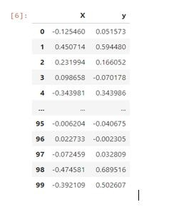

plt.scatter(df['X'],df['y']) plt.title('X vs y')

Text(0.5, 1.0, 'X vs y')

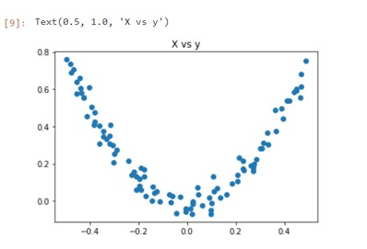

df['pred1'] = df['y'].mean() df

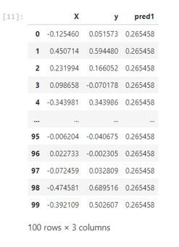

df['res1'] = df['y'] - df['pred1']

df

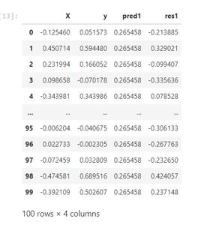

plt.scatter(df['X'],df['y']) plt.plot(df['X'],df['pred1'],color='red')

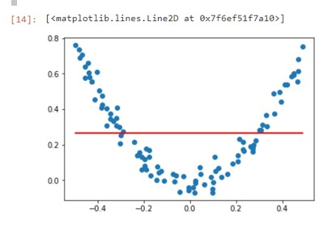

from sklearn.tree import DecisionTreeRegressor

tree1 = DecisionTreeRegressor(max_leaf_nodes=8)

tree1.fit(df['X'].values.reshape(100,1),df['res1'].values)

DecisionTreeRegressor(max_leaf_nodes=8)

from sklearn.tree import plot_tree plot_tree(tree1) plt.show()

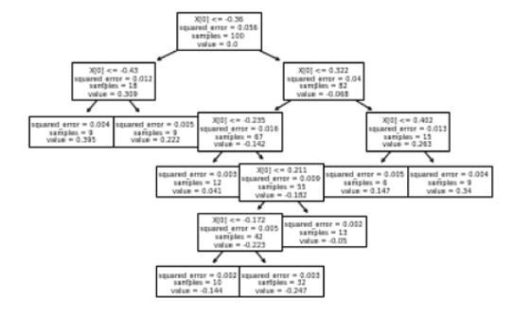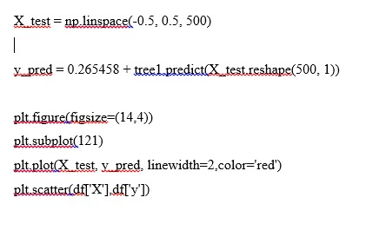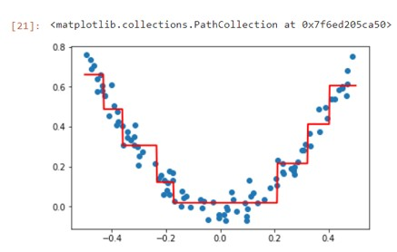

df['pred2'] = 0.265458 + tree1.predict(df['X'].values.reshape(100,1)) df

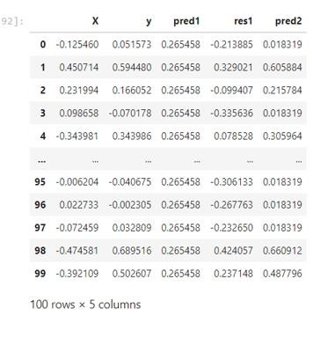

df['res2'] = df['y'] - df['pred2'] df

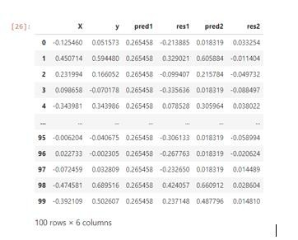

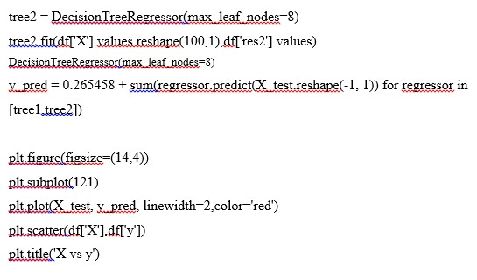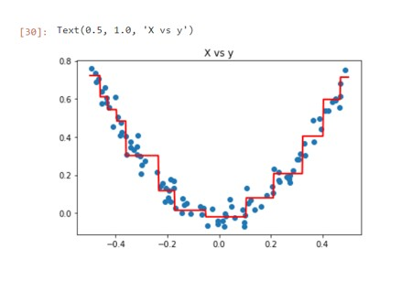

def gradient_boost(X,y,number,lr,count=1,regs=[],foo=None): if number == 0: return else:

# do gradient boosting if count > 1:

y = y - regs[-1].predict(X) else:

foo = y

tree_reg = DecisionTreeRegressor(max_depth=5, random_state=42) tree_reg.fit(X, y)

regs.append(tree_reg)

x1 = np.linspace(-0.5, 0.5, 500) y_pred = sum(lr * regressor.predict(x1.reshape(-1, 1)) for regressor in regs)

print(number) plt.figure() plt.plot(x1, y_pred, linewidth=2) plt.plot(X[:, 0], foo,"r") plt.show()

gradient_boost(X,y,number-1,lr,count+1,regs,foo=foo)

np.random.seed(42)

X = np.random.rand(100, 1) - 0.5 y = 3*X[:, 0]**2 + 0.05 * np.random.randn(100) gradient_boost(X,y,5,lr=1)

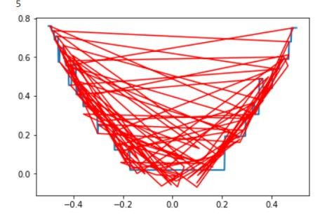

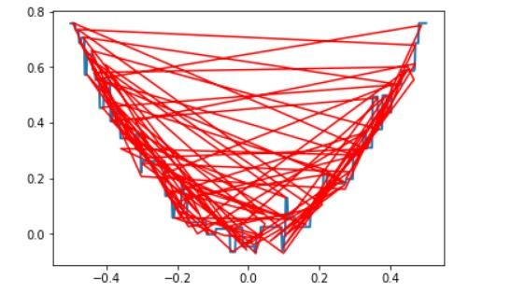

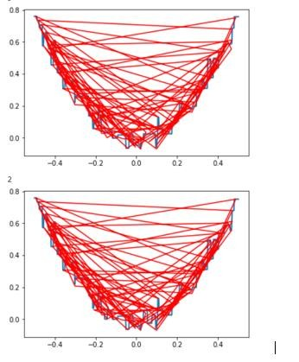

**RESULT:**

Thus, the python program to implement gradient boosting for the standard uniform distribution has been successfully implemented and the results have been verified and analyzed.